TASK 15 - JavaScript - Regular Expression – 2

Name: Anjini Pandey
Reg no.: 24BCE0714

Initial:
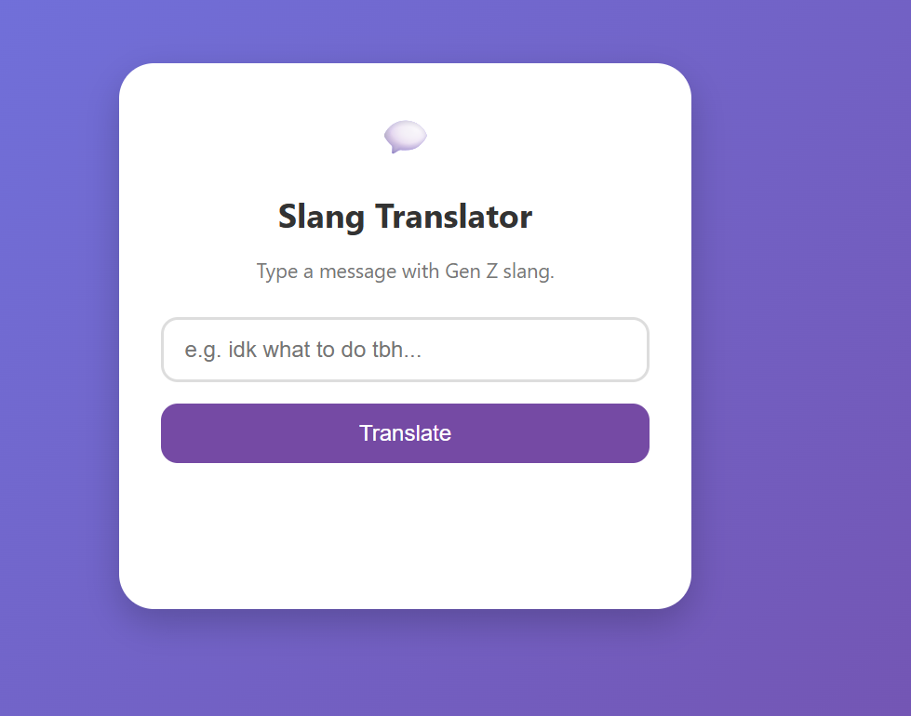

Words:
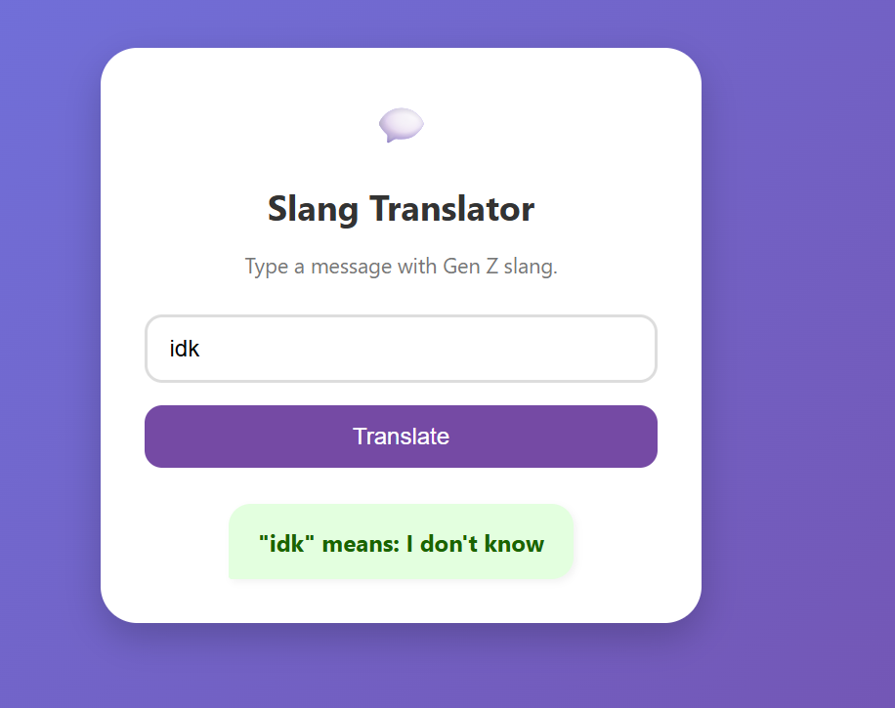
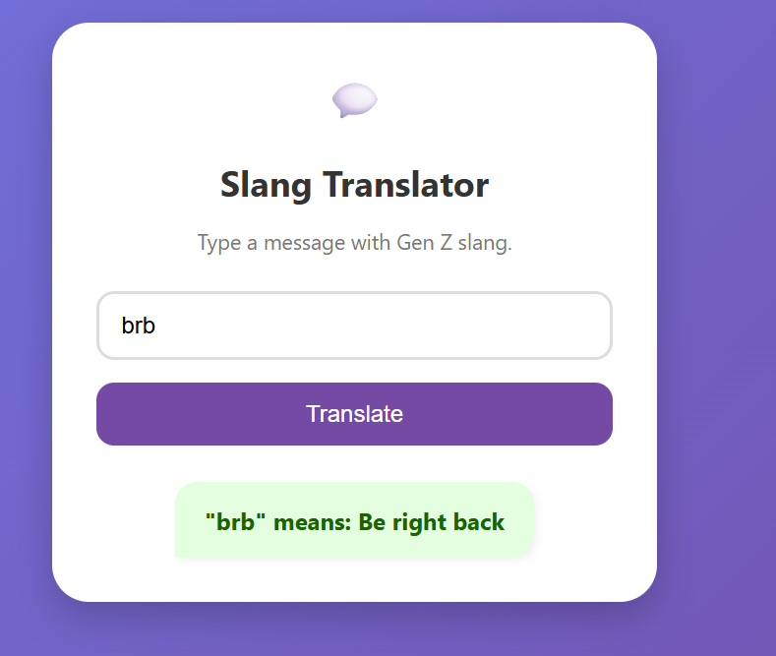
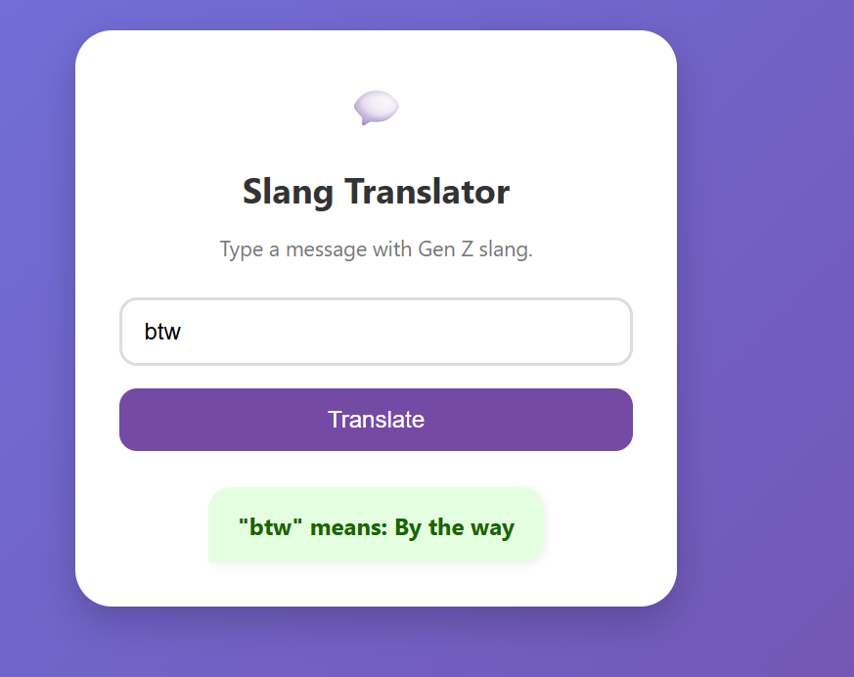
Other words used:
iykyk – If you know, you know
fomo – Fear of missing out
rn – Right now
tbh – To be honest
ngl – Not gonna lie
sus – Suspicious
cap – False / Lie
gg – Good game
lol – Laughing out loud

